1. Log in to GitHub with your account.

2. Fork the repo at <https://github.com/nicomp42/MultiThreadingWinFormsAppAsAGroupProject>

3. Open VS on your desktop

4. Clone the project you forked to your GitHub account. Note: do not clone the original because you don’t have write permission on it and you will not be able to Synch changes to it.

5. From VS open the Solution Explorer:  
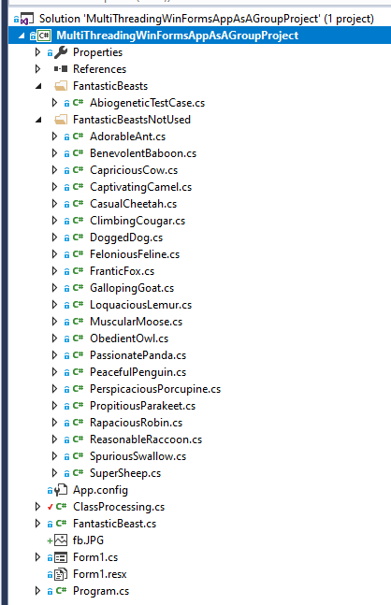

6. Build the project. It should build with no errors. Click the Go button to see the expected behavior.

7. Pick a fantastic beast in the FasntasticBeastsNotUsed folder and drag it to the FantasticBeasts folder. This beast belongs to you now. Don’t mess with any other modules in the project. If you prefer you may create your own beast and add it to the FantasticBeasts folder: simply follow the design of the AbiogeneticTestCase class in the FantasticBeasts folder.

8. Implement the RunThread method in your beast. The method should compute the largest prime factor for the integer in the class member *request* and store the solution in the class member *response*. Your beast must complete its calculations in 5 seconds.   
 public override void RunThread() {

// Use the value in request, compute the largest prime factor,

// store in response

}

9. Verify and validate your code as necessary.

10. Synch your project with your remote repo on Github.

11. Browse to your GitHub repo and submit a Pull Request.